**C PROGRAMMING ASSIGNMENT:**

**4**

DATE: 28.10.21

SUBMITTED BY: -

NAME: MUKTESH MISHRA

BRANCH: CSE

SECTION: B22

ROLL NO.: 21052258

**Program 1:** //evaluation

Code:

#include<stdio.h>

int main(int argc, char const *argv[])

{

    int a,b,c;

    float d;

    a=3;

    b=4;

    c=2;

    d=a+b*c/2-(a-b)*5;

    printf("your evaluated answer is: %f",d);

    return 0;

}

Output:

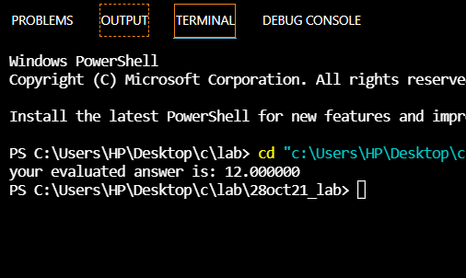

Program 2: //evaluation

Code:

#include<stdio.h>

int main(int argc, char const *argv[])

{

    int a,b,c;

    int d;

    a=2;

    b=3;

    c=4;

    d=a+++--b-++c-++a;

    printf("your evaluated answer is: %d",d);

    return 0;

}

Output:

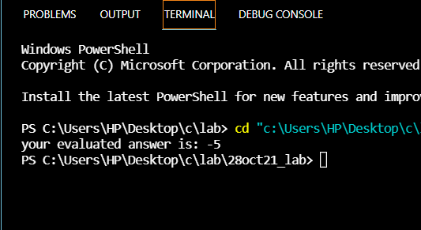

**Program 3:** // evaluation

Code:

#include<stdio.h>

int main(int argc, char const *argv[])

{

    int a,b,c,d;

    a=5;

    b=10;

    c=++a+b--;

    d=a+++--b;

    printf("your evaluated answer is: %d and %d",d,c);

    return 0;

}

Output:

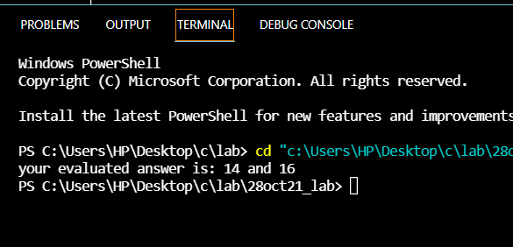

**Program 4:** //evaluation

Code:

#include<stdio.h>

int main(int argc, char const *argv[])

{

    int x;

    float a,b,c,d;

    a=3.54;

    b=4.87;

    c=2.83;

    x=5.40;

    d=3*a*x+10*b*x+20*c*x+10;

    printf("your evaluated answer is: %f",d);

    return 0;

}

Output:

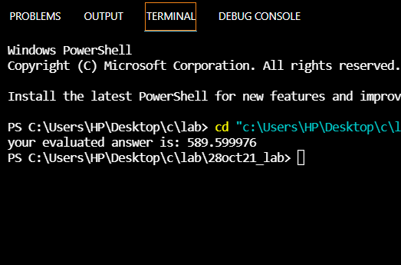

**Program 5:** Write a program to find area of a circle

Code:

#include<stdio.h>

#define pi 3.14

void main()

{

    float r,a;

    printf("Enter the radius of the circle:\n");

    scanf("%f",&r);

    a=pi*r*r;

    printf("Area of circle is: %f",a);

}

Output:

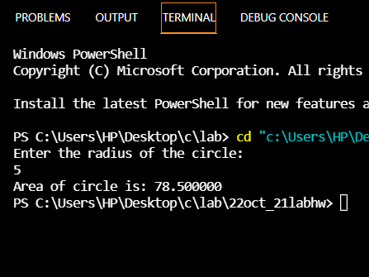

**Program 6:** Write a program to convert degree Celsius to Fahrenheit.

Code:

#include<stdio.h>

int main(int argc, char const *argv[])

{

    float c,f;

    printf("Enter the degree in celsius");

    scanf("%f",&c);

    f=(c*(9/5.0f))+32;

    printf("Your conversion answer is: %f",f);

    return 0;

}

Output:

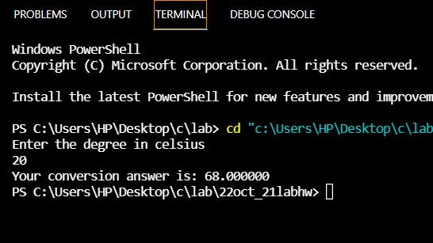

**Program 7:** Write a program to find volume of a cylinder

Code:

#include<stdio.h>

#define pi 3.14

int main(int argc, char const *argv[])

{

    float r,h,a;

    printf("Enter the radius\n");

    scanf("%f",&r);

    printf("Enter the height\n");

    scanf("%f",&h);

    a=pi*r*r*h;

    printf("The volume of the cylinder is %f",a);

    return 0;

}

Output:

